The Melter
Real name: Bruno Horgan.
First appearance: Tales of Suspense 47.
Died in: Avengers 263, at the hands of the Scourge.
What's His Problem? A failed industrialist who went bankrupt when government inspectors proved he was using faulty materials, Bruno Horgan discovered that a malfunctioning radar device in one of his defunct factories could project a beam that liquefied iron. Studying and duplicating the process, Horgan embarked on a new career as a costumed saboteur called the Melter. His first targets were the factories of his chief rival, Anthony Stark, who defeated the Melter repeatedly in his armored guise as Iron Man.
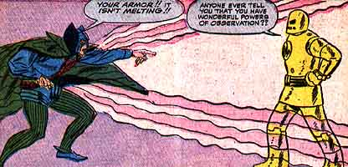
Abilities: The Melter was a competent unarmed combatant with considerable engineering and design skills.
Weapons: The Melter's melting ray does not actually project heat; instead, it broadcasts on a frequency that loosens molecular bonds, causing solids to turn to liquids. Originally, the beam could affect only iron; modifications by Baron Zemo later enabled it to melt any metal. Still later, Horgan coerced Anthony Stark into modifying the beam so that it could affect metal, stone, wood or flesh when set to the proper frequency for each. At first, the Melter wore his ray device as a chest-mounted projector. Later, he redesigned it as a hand-held gun. At the time of his death, he wore his ray device as a belt-mounted projector. The Melter sometimes housed smaller models of the melting ray projector in the nodes on his helmet.
Favorite quote: "Look, Avengers! First, I melt a lamp post--next, I'll turn my invincible beam on you!" (Avengers 16. The diabolically demonstrative Melter, evidently forgetting in the heat of the moment that his melting beam was then only applicable to metal.)
Heroes He Kept Running Into: Iron Man trounced the Melter a zillion times despite his armor's vulnerability to the Melter's chosen weapon. As a longtime founding member of the Masters of Evil, Melter also got beaten up by Iron Man's Avengers teammates from time to time.
People Who Think He's Not So Bad: Melter had recurring criminal associates such as the Masters of Evil, Whiplash, Blizzard and his sometime employer Justin Hammer, but no pals as such. Guess brandishing a weapon capable of melting human flesh doesn't do much for your popularity.
Most despicable act: Toss-up between the attempted murder of Avengers butler Jarvis (Avengers 55) and an attack on the then-hospitalized Thing (Marvel Two-in-One 96). The Melter was not being particularly sporting in either case.

